University of Newcastle
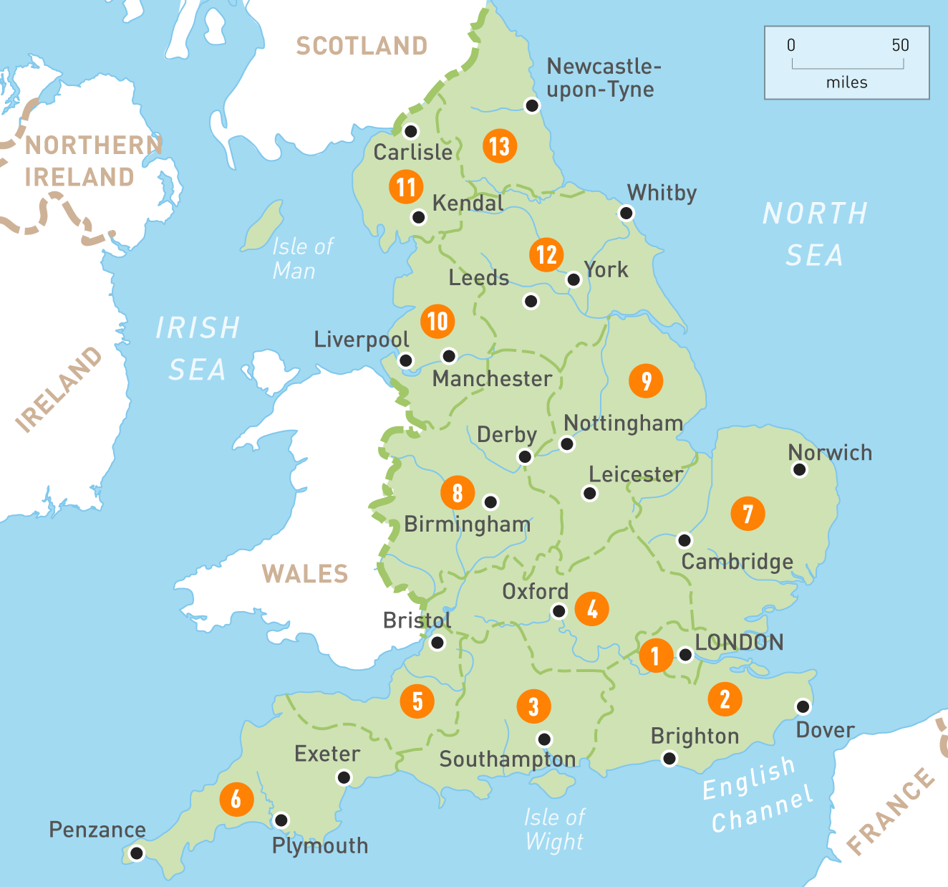
Univerrsity of Derby
University of Herts, Univerity of Northampton University of Beds
UAL, University of Westminster, University of west London, London Metropoliton
University of Birmingham
University of Manchester
University of Leeds
Solent, University of Southampton
University of Brighton

