Location Recce
Production title: Promotional video
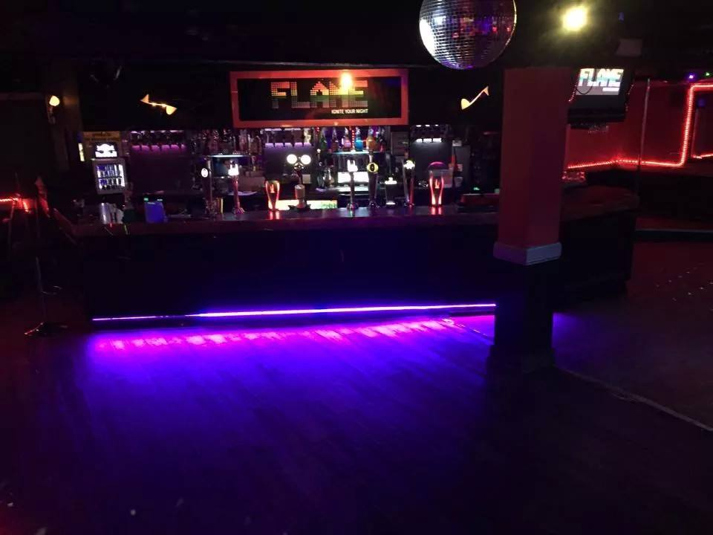

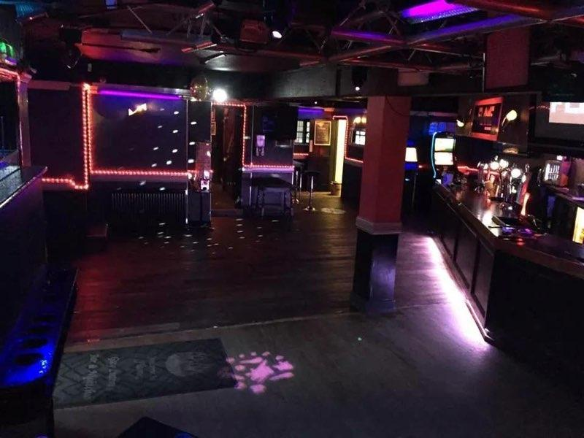

Location name | Flame
Address | 58 Wellington St, Luton LU1 2QH
Points of interest | This is where I will be filming as this is what the promotional video is for.
Justification for suitability | You are able to see that the club is a huge open space and I will therefore have loads of room to film on the night. The club holds around 350 maximum which means the club does look packed when filled.

