Location Recce
Production title:
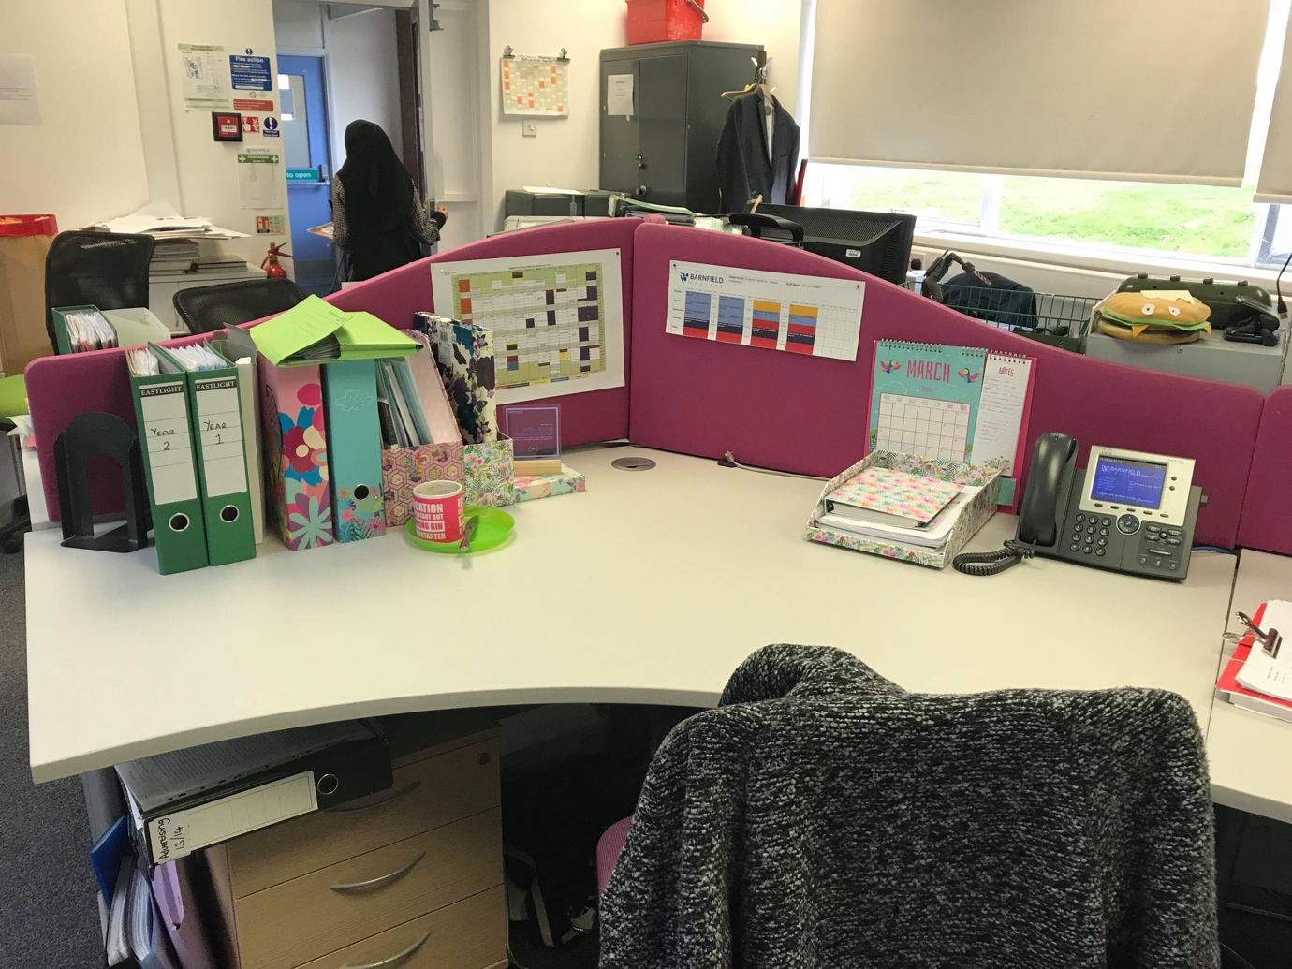

Location name | Barnfield college creative arts office
Address | Barnfield college
Points of interest | The character works in an office.
Justification for suitability | Our character works in an office and it make more sense for us to use the resources that every crew member can easily get to instead of finding alternative spaces.

