Location Recce
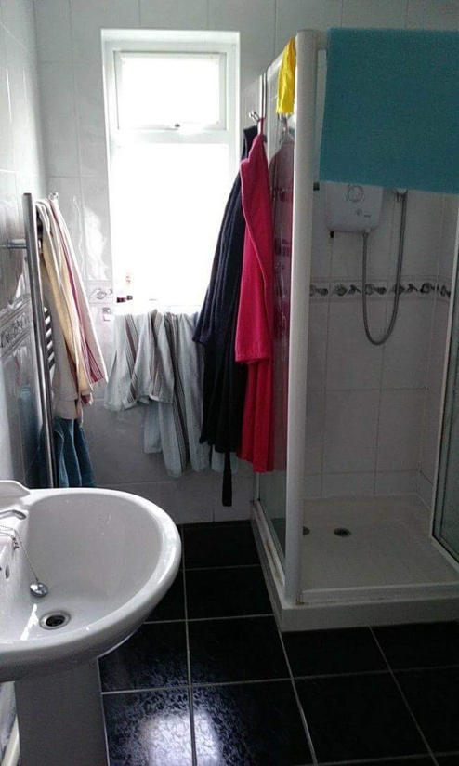
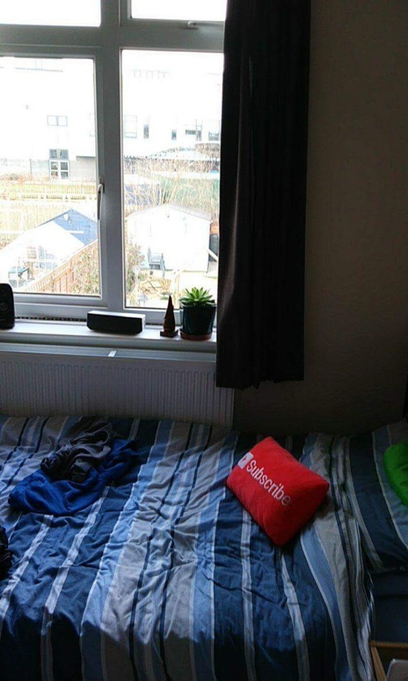
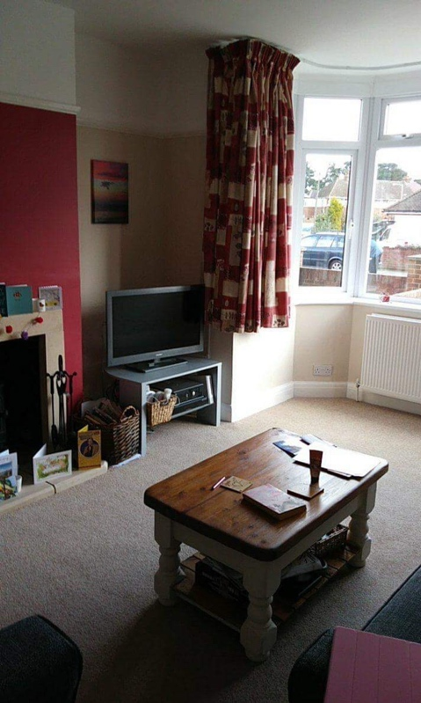
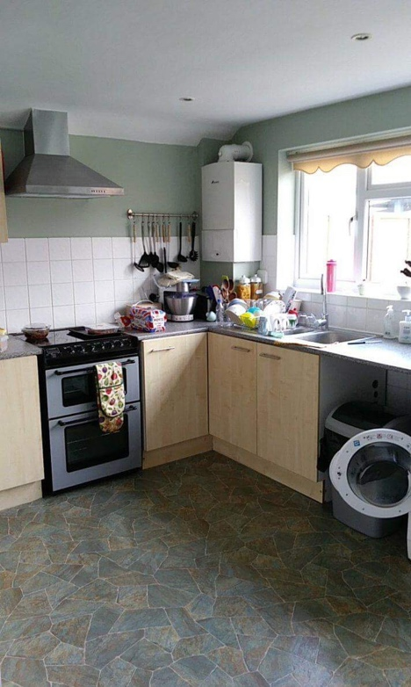
Production title:

Location name | Directors house
Address | 45 Mixes Hill Road, Luton Beds, LU2 72X
Points of interest | Natural lighting, all the rooms we are looking for and it fits our characters lifestyle.
Justification for suitability | We chose this location over any others because it contains all the rooms we need for filming, and the house has plenty of room for filming equipment.

